MA323 Lab10 Report
Pavan Kumar A
210123043

Q1)

Where, , and

Therefore the intervals for each PDF come out to be:

The average of the samples generated is -0.31989
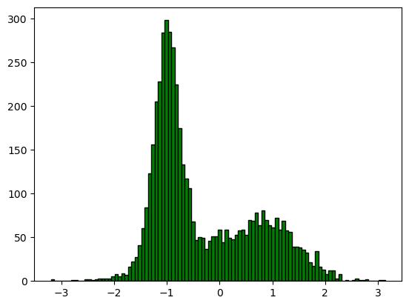

Observations:
- Since the Interval [0,0.5] corresponding to k=1 is the largest, PDFhas the highest number of samples generated and thus the mean is closer to -1.
- There is a clear “bump” in the frequency near the means of each distribution used in the mixture, i.e, -1, 0, 1.

Q2)
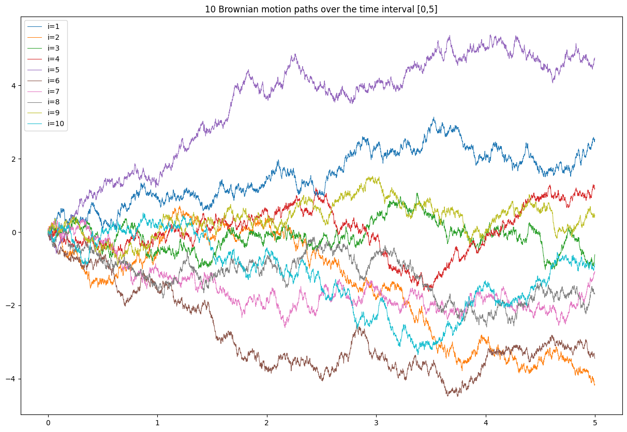

The estimated value of E[2] from the 10 sample paths generated is -0.02848

The estimated value of E[5] from the 10 sample paths generated is -0.29422

Observations:
- Each step of the Brownian motion path are independent and follow different distributions which can be seen in the plot.
- Since the variances at t=2 and t=5 are very high, the estimate from only 10 samples is not very accurate and is unreliable.

Q3)
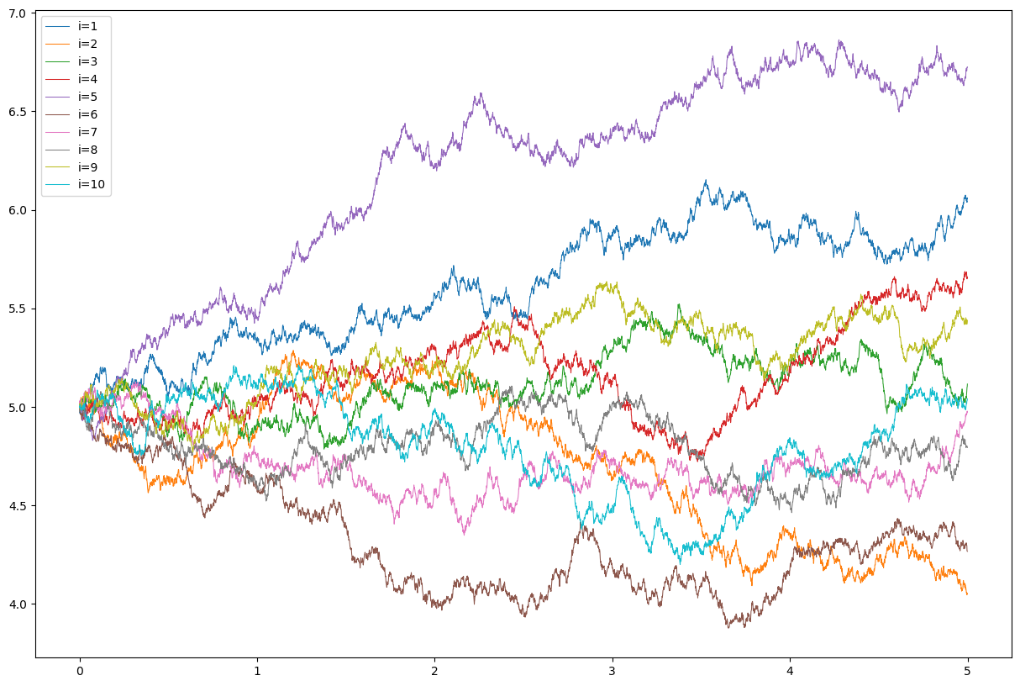
The estimated value of X[2] from the 10 sample paths generated is 5.08714

The estimated value of X[5] from the 10 sample paths generated is 5.28333

Observations:
- The path in this case is same the previous one except it is moved up, this is because we use the same seed when generating the random numbers from standard normal distribution.
- The estimates in this case too are unreliable as the variance are too high.

